DAY – 1 TASK

1. Java Setup Verification
Task:
Write a Java program to print the message "Java Environment Setup Successful".
Concepts: Setup, JVM
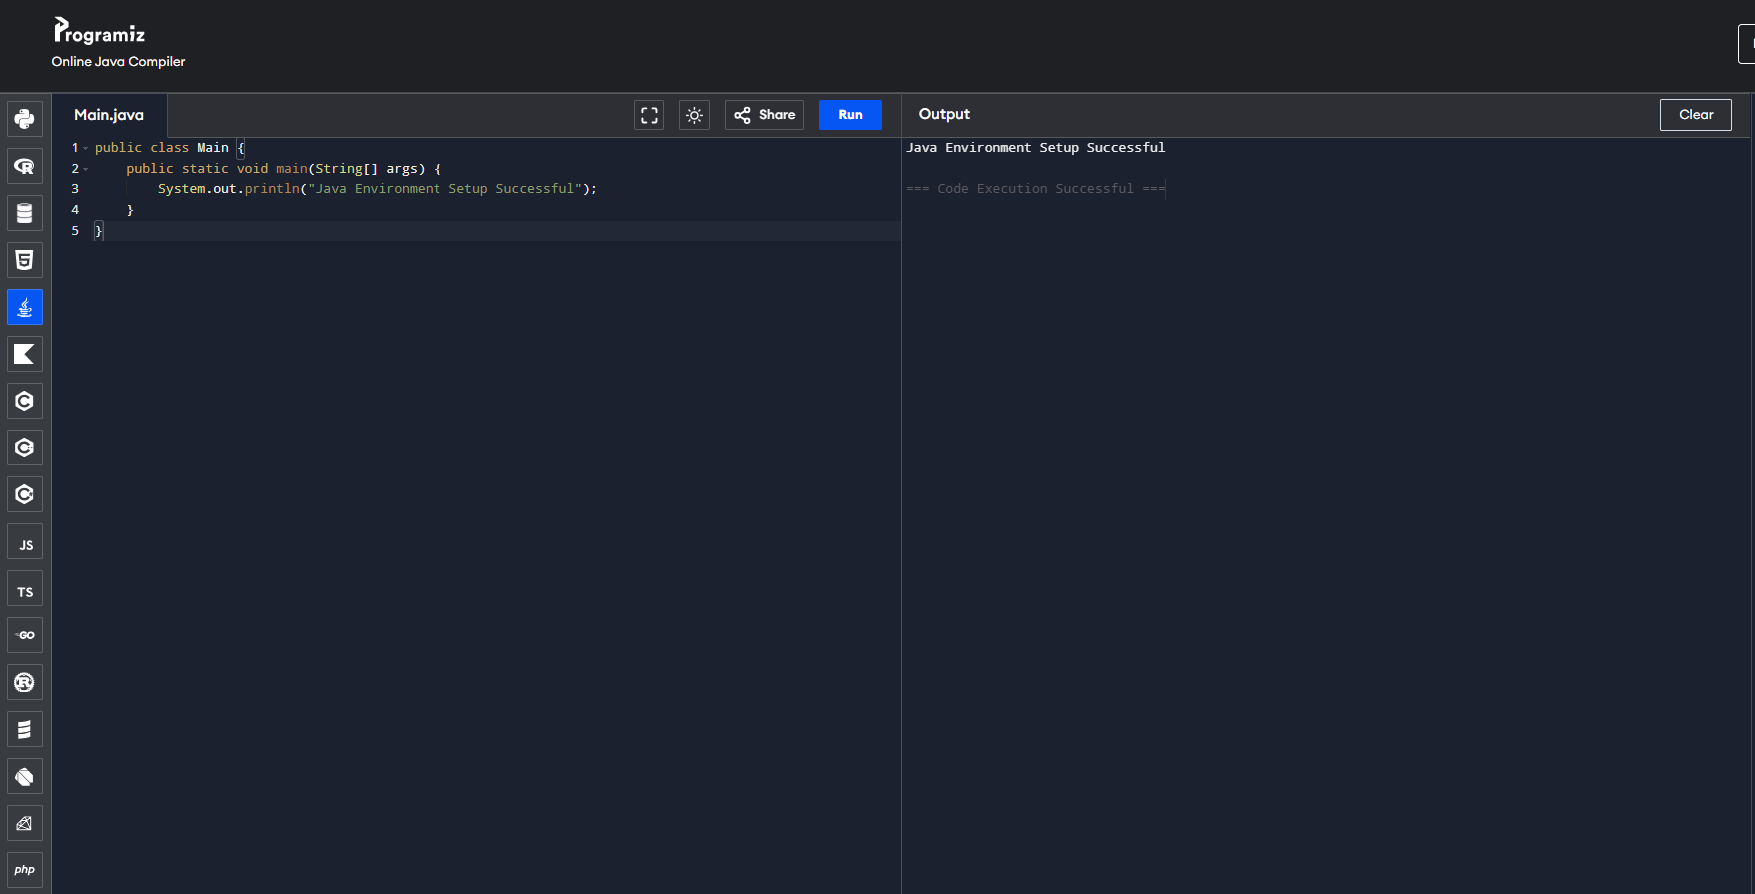

2. Student Information
Task:
Create variables to store:
- Student name
- Age
- Department
Display them on the screen.
Concepts: Variables, Primitive Data Types
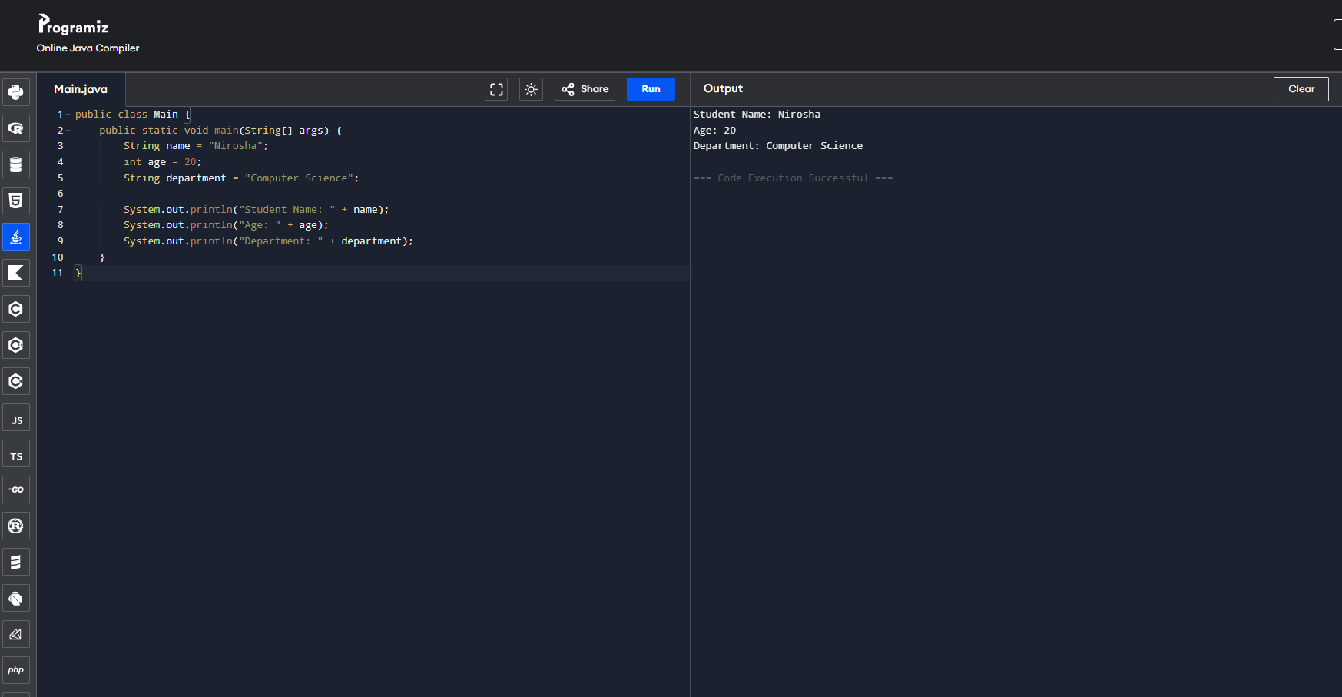

3. Basic Calculator (Addition)
Task:
Declare two integer variables and display their:
- Sum
- Difference
- Product
Concepts: Variables, Operators
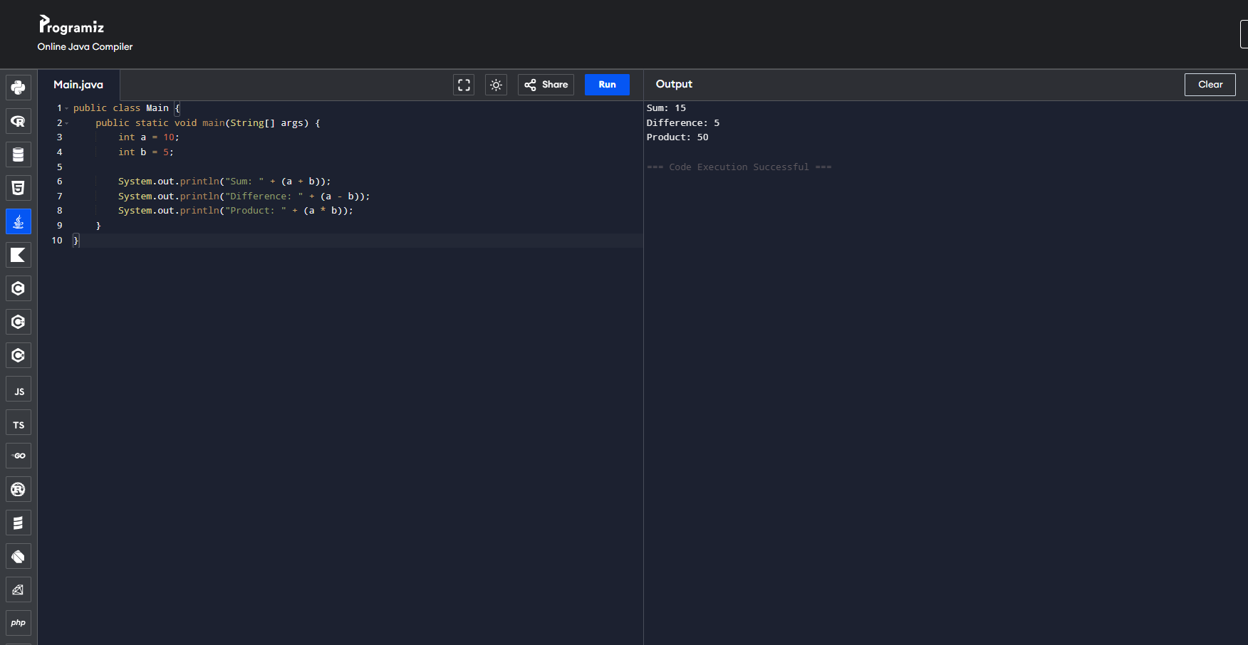

4. Even or Odd Number
Task:
Take a number and check whether it is even or odd.
Concepts: Operators, Conditionals
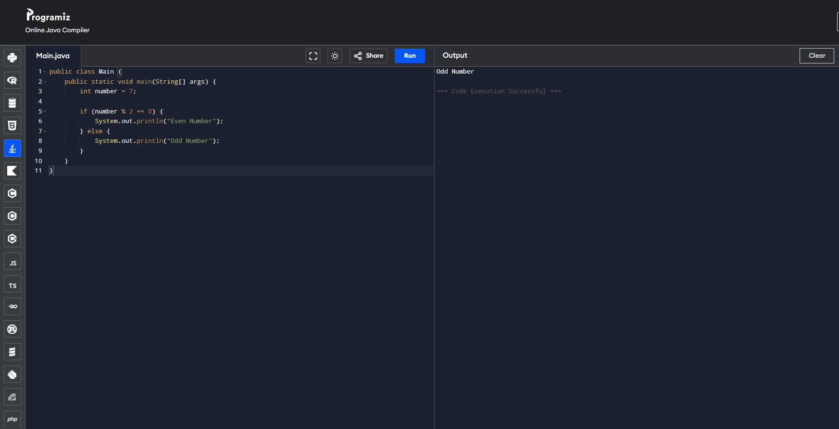

5. Voting Eligibility
Task:
Check whether a person is eligible to vote.
Condition:
Age >= 18 → Eligible
Age < 18 → Not Eligible
Concepts: if statement
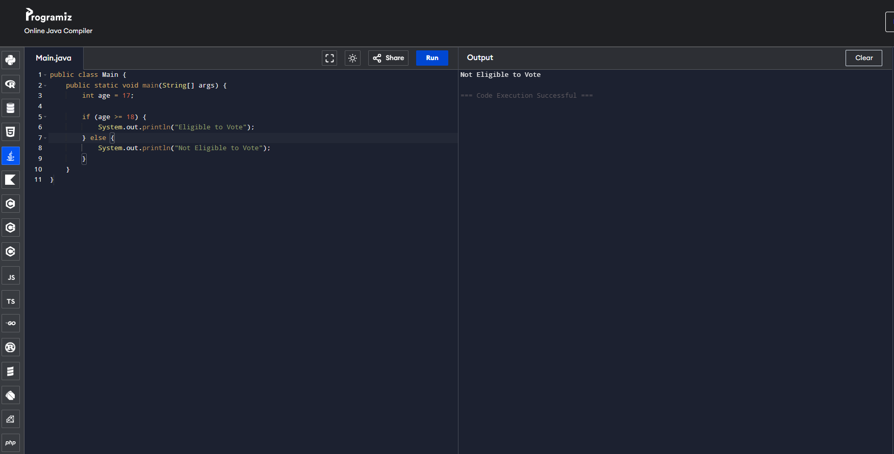

6. Temperature Check
Task:
If temperature is greater than 30, print Hot Weather otherwise print Normal Weather.
Concepts: if–else
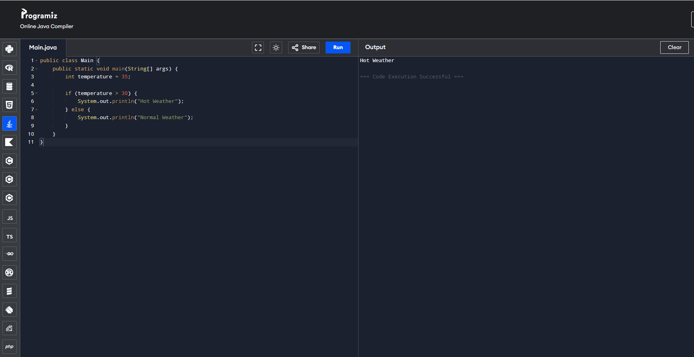

7. Maximum Number
Task:
Find the largest number between two numbers using the ternary operator.
Concepts: Ternary Operator
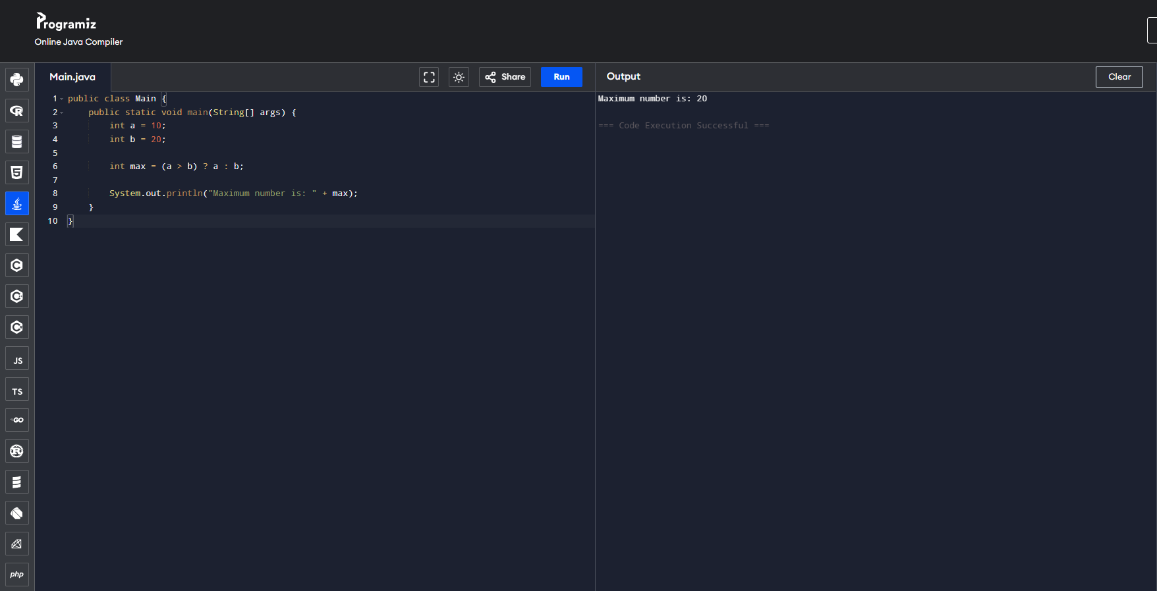

Intermediate Level Tasks
8. User Input Program
Task:
Use Scanner to take input:
- Name
- Age
- City
Display the information.
Concepts: Scanner, Variables
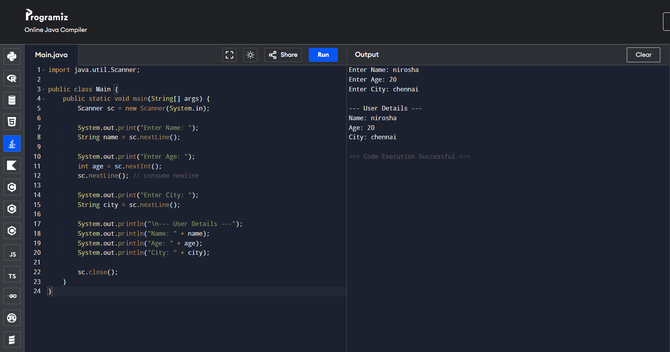

9. Arithmetic Calculator
Task:
Take two numbers from the user and perform:
- Addition
- Subtraction
- Multiplication
- Division
Concepts: Operators, Scanner
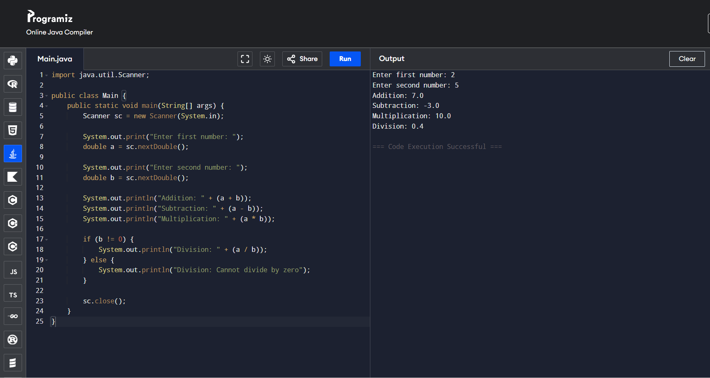

10. Grade Calculator
Task:
Calculate student grade based on marks.
Marks | Grade
90+ | A
70–89 | B
50–69 | C
Below 50 | Fail
Concepts: else-if ladder
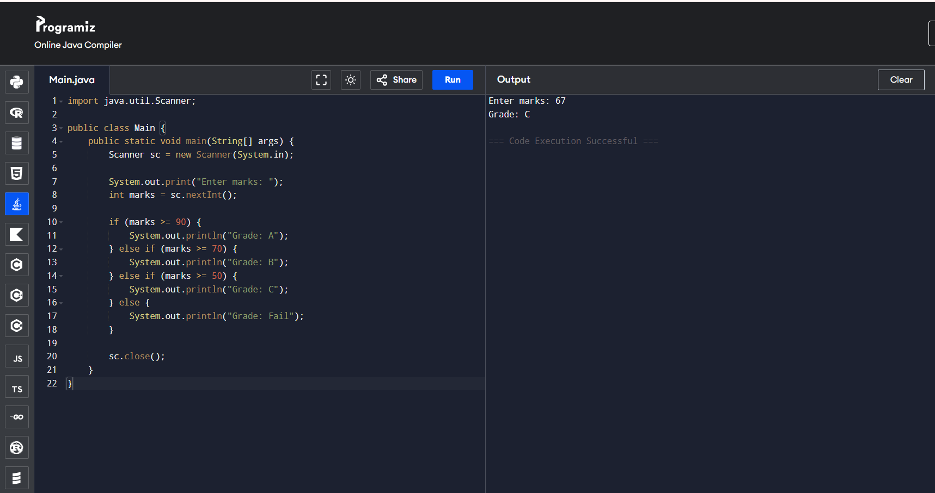

11. Simple Menu System
Task:
Create a menu using switch:
1 → Pizza
2 → Burger
3 → Sandwich
Display the selected item.
Concepts: Switch
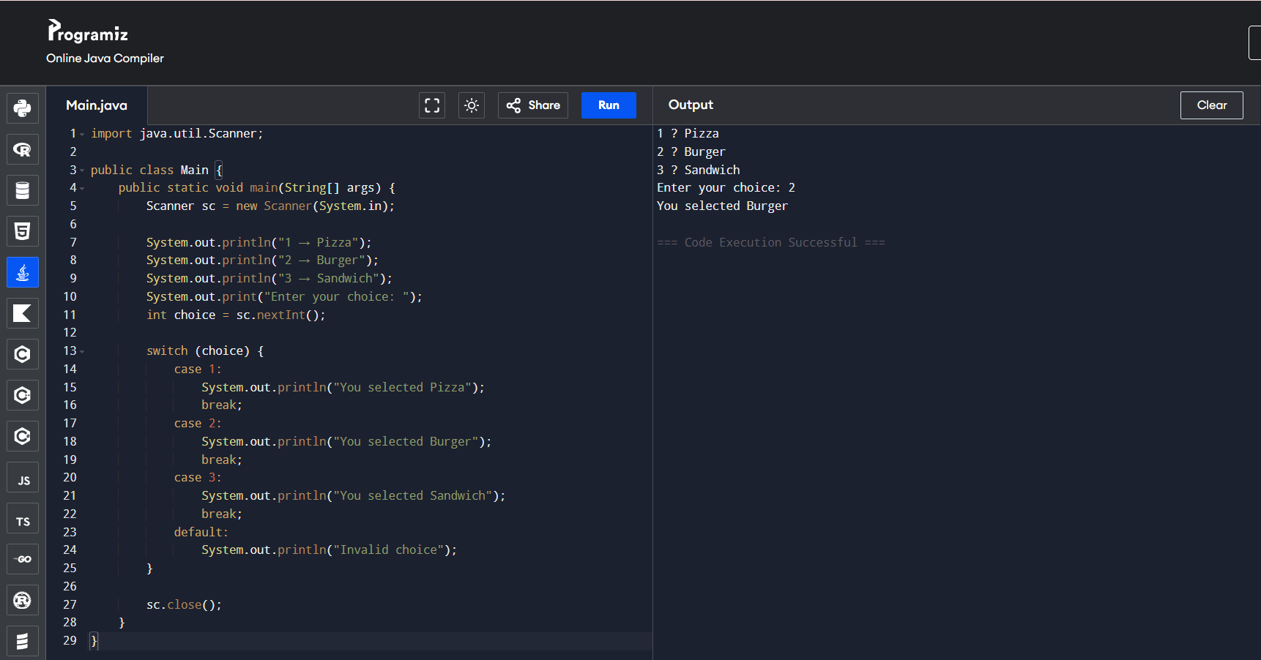

12. Electricity Bill
Task:
Calculate electricity bill.
1 unit = ₹5
Take units from user and calculate bill.
Concepts: Variables, Operators, Scanner
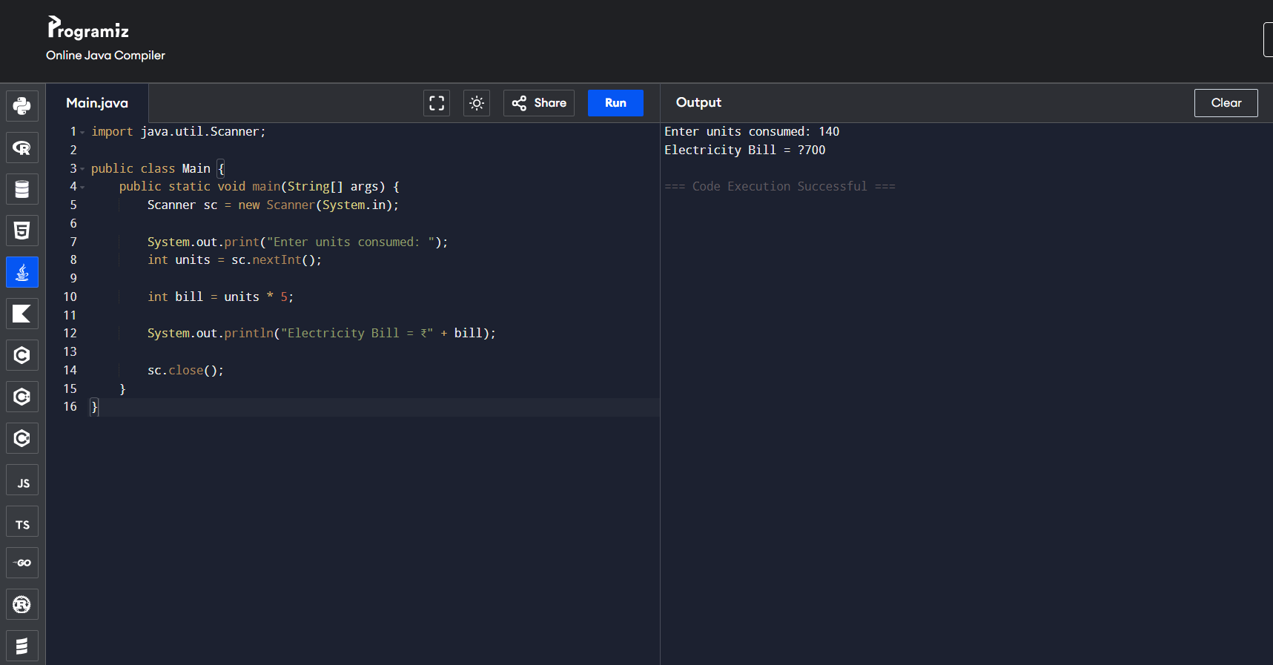

13. Login System
Task:
Ask the user to enter a password.
Password = 1234
If correct → Login Successful
Otherwise → Access Denied
Concepts: Conditionals, Scanner
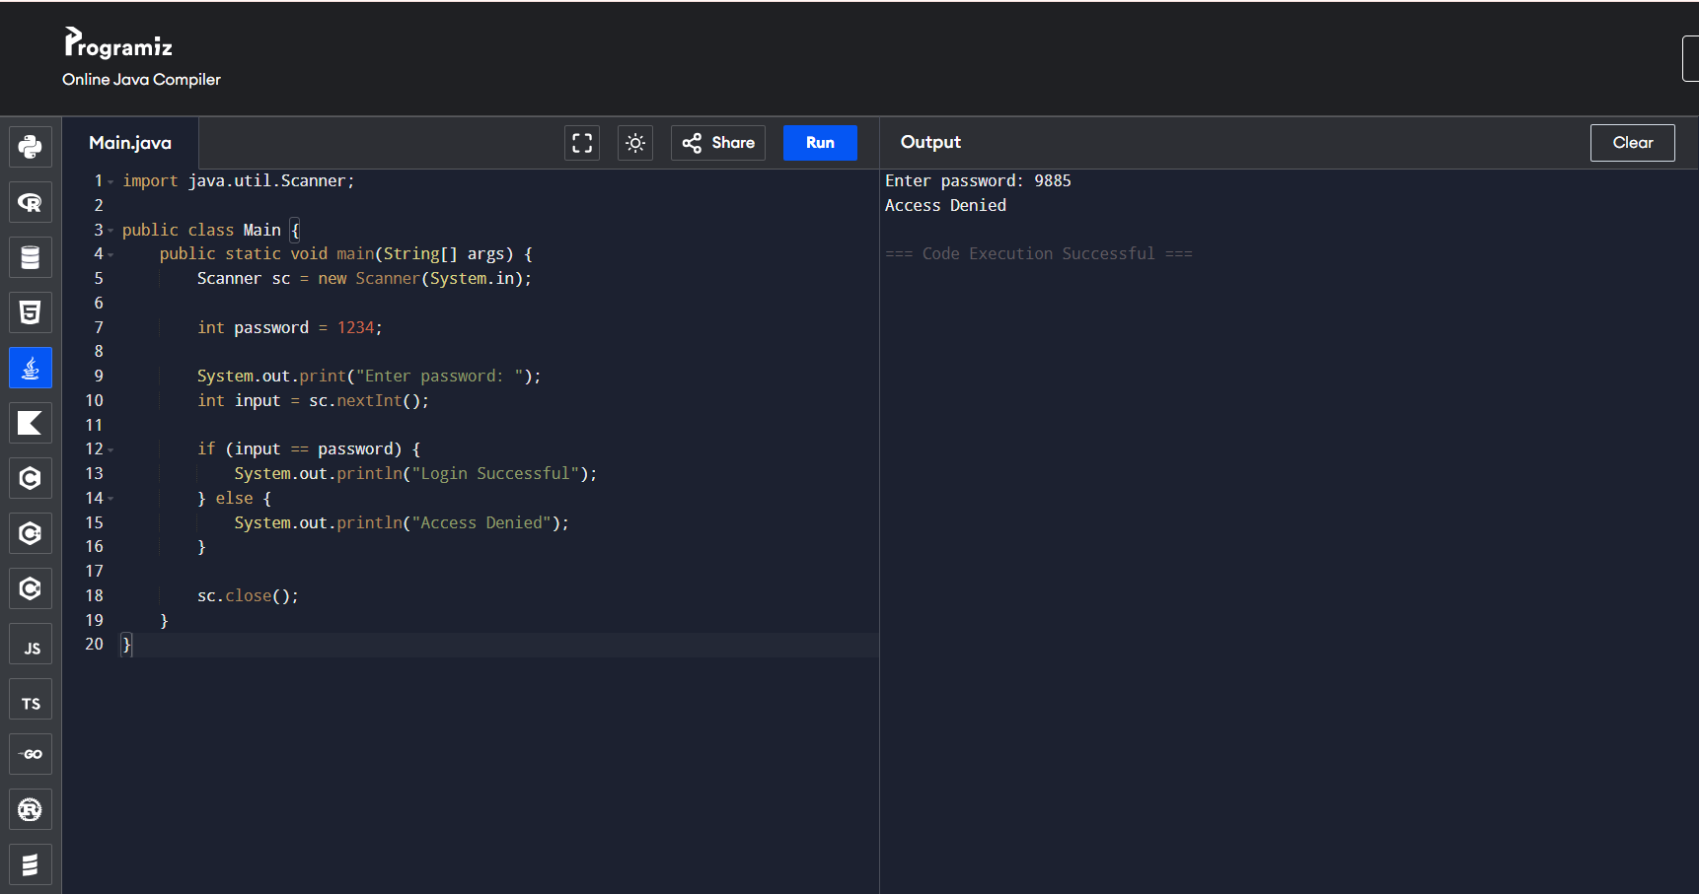

Advanced Level Tasks
14. Multi-Operation Calculator
Task:
Create a calculator using switch with operations:
1 Addition
2 Subtraction
3 Multiplication
4 Division
User selects operation.
Concepts: Switch, Scanner, Operators
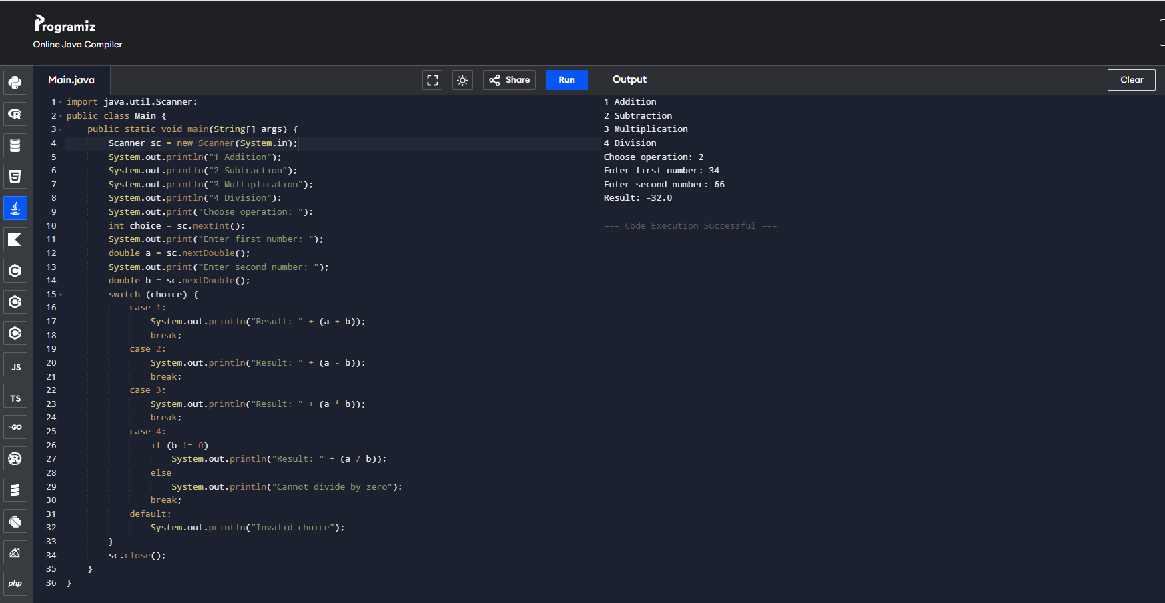

15. Banking Withdrawal System
Task:
Simulate ATM withdrawal.
Conditions:
Balance = 10000
If withdrawal > balance → Insufficient balance
Otherwise deduct amount
Concepts: Variables, Conditionals
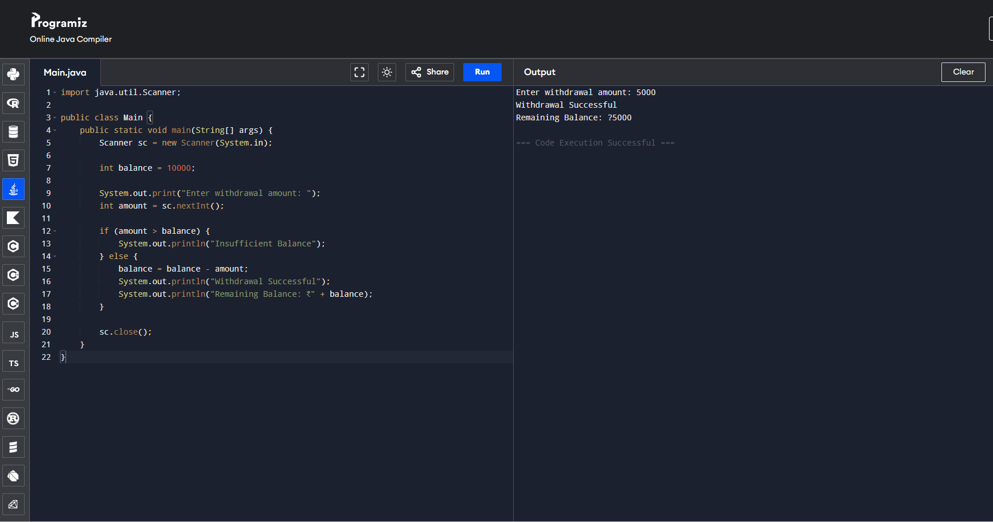

16. Online Shopping Discount
Task:
Calculate discount based on purchase amount.
Amount | Discount
>5000 | 20%
>2000 | 10%
Otherwise | No discount
Concepts: else-if
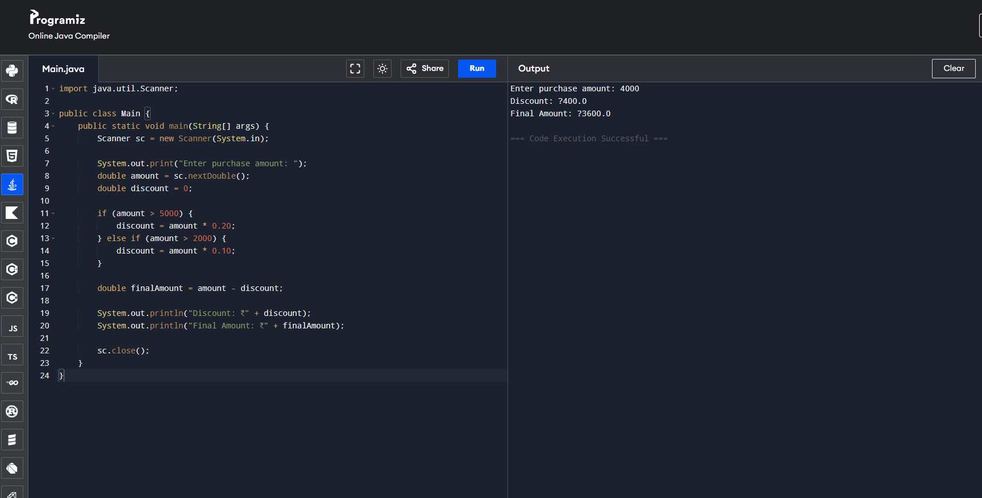

17. Traffic Signal Program
Task:
Create a program using switch.
Red → Stop
Yellow → Ready
Green → Go
Concepts: Switch statement
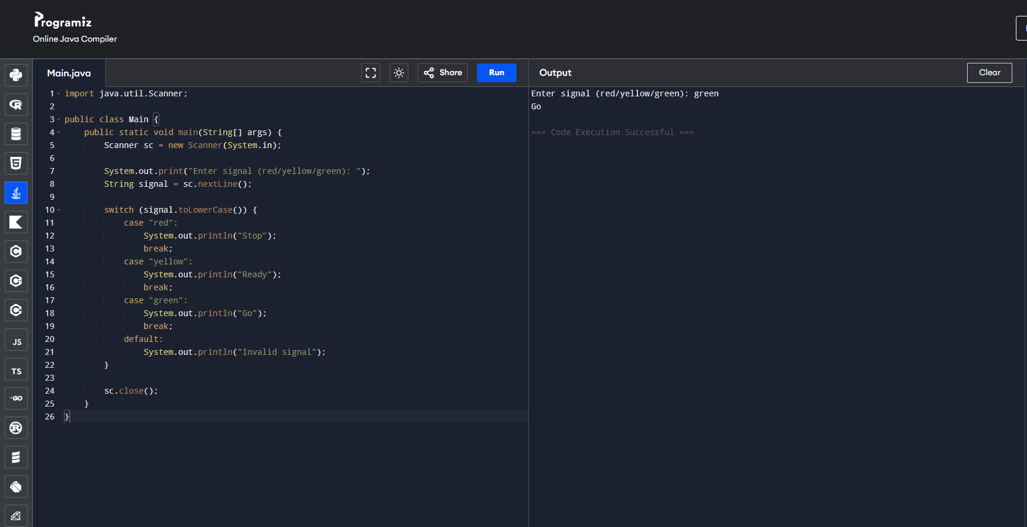

18. Smart Temperature System
Task:
Check temperature and display condition.
<15 → Cold
15–30 → Normal
>30 → Hot
Concepts: Conditionals
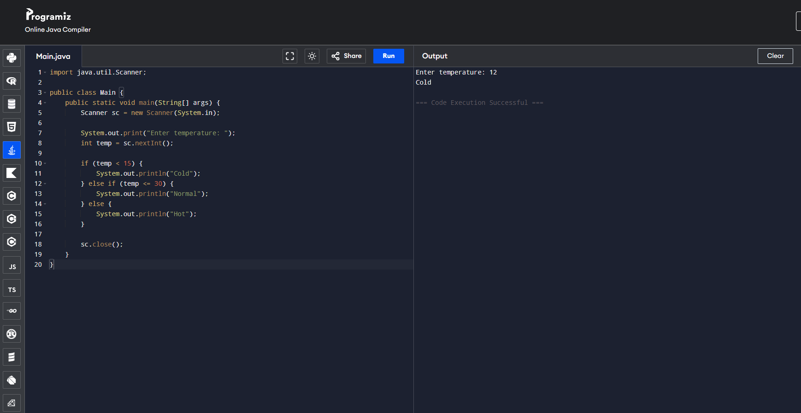

19. Maximum of Three Numbers
Task:
Take three numbers from the user and display the largest number.
Concepts: if–else ladder, operators
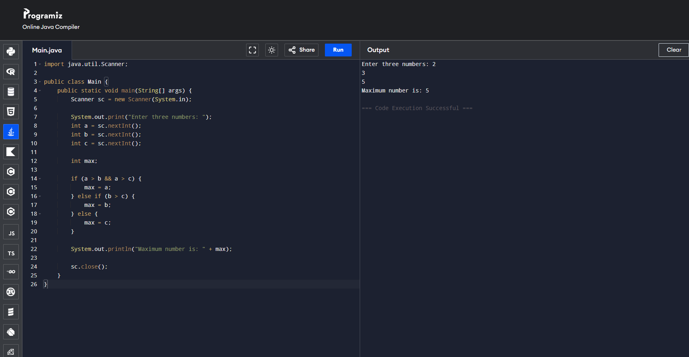

20. Simple Banking Menu
Task:
Create a banking system using switch.
Menu:
1 Check Balance
2 Deposit
3 Withdraw
4 Exit
Concepts: Switch, Scanner, Variables
